CROYDON WRITER OF THE MONTH
March 2026

WINNER

Little Weed

By Peter Hankins

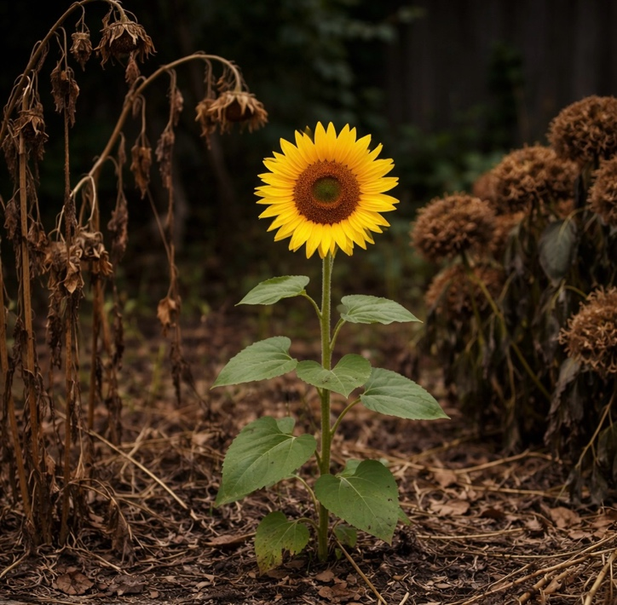
I have so many dead plants. In my greenhouse and garden stand rows of pots containing corpses. Here a dried brown stem, there the slimy black remnants of trailing leaves. The plants I did not water, the plants I watered too much. The ones that died suddenly for no obvious reason, the ones that went slowly, shedding one leaf then another, wilting daily by degrees and begging for help that never came. Some people, they say, have green fingers: mine must be red, like the bloodstained hands of some tyrant who slew a multitude of innocents. That greenhouse is to plants what the catacombs of Palermo are to human beings: an extensive museum of deaths, each different in its circumstances and details, yet all fundamentally the same journey to the universal Terminus.
So it was with surprise and pleasure that one spring morning I noticed a green shoot in one of the many bare patches that fill my garden.
‘It’s a weed,’ said Jane, my wife.
‘No, I vaguely recognise it,’ I said, ‘and it’s growing right by that cane that a plant was once tied to. I think I put it in two years ago and it died right back. But under the soil it’s been gathering strength, preparing roots and organising its forces. Now it’s coming back, ready to establish itself. I just don’t remember what kind of plant it actually was.’
‘That’s not a cane,’ she insisted, ‘that’s the remains of the camellia you planted in November.’
‘Surely that was somewhere else.’
‘That thing is just a weed, honestly.’
‘I don’t think so.’ But we called the new arrival Little Weed after the flower that was the best friend of the Flowerpot Men in the old children’s TV show. And it grew like a weed. One small green leaf unfurled and expanded while the shoot pushed up till it was the length of my thumb. One day it looked dry, and I got out my pink plastic watering can. While I hesitated, Jane came up.
‘You’re giving it the Can of Death?’ she asked.
‘Just a bit of water.’
‘You know that’s the can you use for weed killer? The plain water one is green.’ She was right, and just in time.
Little Weed put out another leaf, and another: she was two hand’s breadths tall by now and if anything, picking up speed.
One morning I found that a fox had been by and for inscrutable vulpine reasons dug a large hole in the flower bed. A peony was totally uprooted, but somehow the excavation just missed Little Weed, a fine straight plant that was now knee high. A day of high winds flattened my hollyhocks, but the Weed still stood, dauntless and flourishing. Nothing could stop her.
‘I feel this is the moral side of gardening,’ I said one morning as Jane and I stood admiring Little Weed’s growth, like enthusiastic aunties. ‘I mean, it’s like life. So much goes wrong, so many hopes are blighted. But there’s always a new start, fresh hope, and at last, unexpected success.’
‘I don’t know whether you can claim this as a success,’ she said, ‘you didn’t plan it, and it’s the random result of some bird dropping a seed or something like that. All you’ve done is fail to kill it. Although given your record, that might actually be some sort of achievement.’
‘Listen,’ I said, ‘there are doctors out there who’ve made good careers out of failing to kill people. I’m proud. I feel vindicated. Forgiven at last by Mother Nature. She wants peace between us. This is an olive branch.’
‘More of a sunflower, I think,’ said Jane.
That seemed a fair assessment. Little Weed was not little anymore. By the time a flower bud appeared, she could look me in the eye.
The day of glory came at last and a wide yellow flower with a beguiling dark centre opened up. Van Gogh never got so much pleasure from all his blooms as I got from this single one, with its daring echo of the mighty solar disc.
‘Magnificent!’ I breathed quietly to myself.
Next day she was dead, broken off close to the ground. I’ll never know whether it was the foxes, some gnawing creature or a sudden gust of wind taking advantage of her newly weighty blossom. But Little Weed will live in my heart forever.
OTHER ENTRIES
in no particular order

A Spring
By Maggie Smith
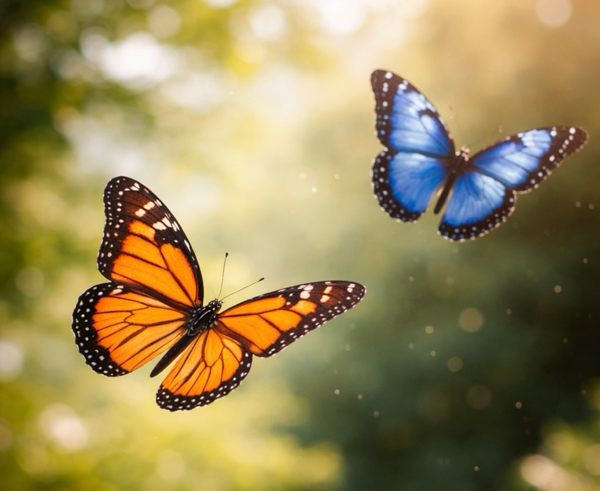

A chaffinch sang sweetly on the apple tree bough,
And fleecy white clouds floated up in the sky,
the honeybees buzzed on the rosy, pink blossom,
and two butterflies floated by.

A translucent sun beetle ran through the clover,
from behind its green leaf peeped a primrose so shy,
A dewdrop shone brightly on the tip of a rosebud,
And two butterflies floated by.

A daffodil waved in the breeze to a hyacinth,
Round the crystal blue dome flew a swallow so high,
A spider spun silk in the rays of the sunshine,
And two butterflies floated by.

Political Dog

By Dr Moss

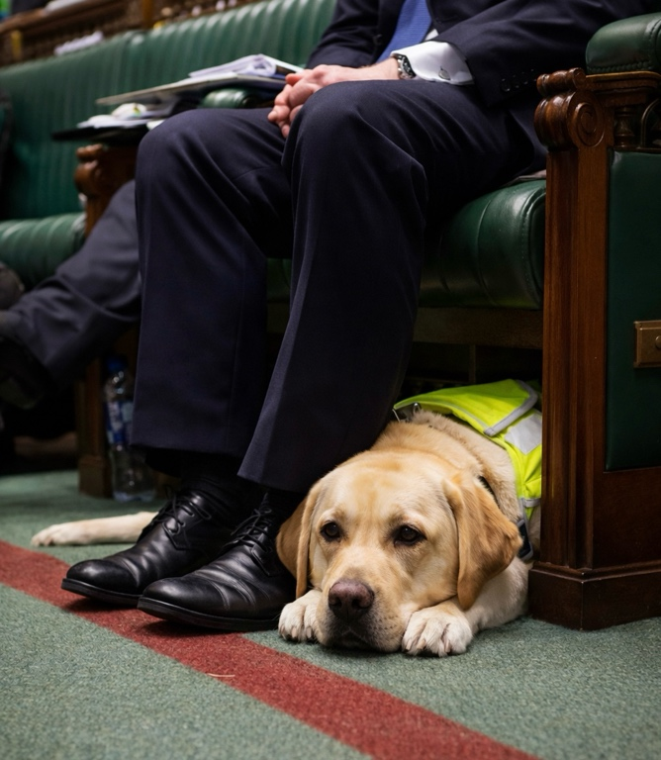
Retirement has given me something that working life rarely allowed: time. On this particular afternoon I found myself with an unexpected free hour. The house was quiet and in reasonable order. I sat on the sofa with the television remote in my hand, an object I seldom use, and began turning through the channels in search of something that might hold my attention long enough to stir a few words onto paper.
Most programmes failed the test. Some were trivial, others repetitive, and many sounded suspiciously like carefully polished echoes of whatever the government wished the public to hear that week.
Eventually I stopped on a live broadcast from Parliament. I had never watched one before. The debate was proceeding in the usual fashion, orderly on the surface, yet strangely theatrical. Speeches were delivered with great confidence, though not always with great clarity.
Yet it was not the politicians who held my attention.
Near the front bench lay a guide dog.
I have always admired working animals. Their honesty is refreshing when compared with certain human professions. The dog lay calmly beside his owner, his head resting on his paws. I decided to call him Marko, or precisely as a tradition in the parliament to call him “the Right Honourable Marko” as they like to call each other.
One could not help respecting Marko. Each day he must guide his owner through busy streets, across roads filled with impatient traffic, through stations, pavements, and crowds. Eventually he leads his human companion through the long corridors and stone doorways of Parliament itself, a building famous for debate, though not always for resolution.
The discussion in the chamber soon began in earnest. For a brief moment I wondered whether they might address matters that affect ordinary people: the long queues for medical appointments with GP, the patients waiting in hospital corridors, or the growing difficulties of daily life.
They did not.
Instead, my thoughts returned to the Right Honourable Marko.
His eyes were closed, though one ear remained half-raised as if monitoring the rising tide of voices around him. Suddenly a Member of Parliament stood and asked a question. The request was simple: a clear answer of yes or no.
I found myself murmuring quietly, “Good luck with that.”
Marko lifted his head slightly.
Instead of yes or no, another politician rose and delivered a speech. It wandered through complicated language about reviews, committees, consultations, frameworks, and future considerations. The words travelled a long distance without arriving anywhere in particular.
To a dog, I imagine, such reasoning would resemble watching a squirrel zigzag across a park: energetic, confusing, and impossible to follow.
Soon another politician repeated the question, louder this time. The chamber responded with cheers, groans, and theatrical outrage.
At this point Marko opened his eyes fully and looked toward the speakers.
If a dog can appear puzzled, he did.
Perhaps he was waiting patiently for the two simple words that would settle the matter.
Yes.
Or no.
Dogs understand such logic perfectly. During training, when the instructor says “sit,” the dog sits. There is no committee discussion about the strategic future of sitting.
Imagine, however, if dogs behaved like politicians.
“While I recognise the importance of sitting,” Marko might say, “a comprehensive review of current sitting practices is underway; panel of experienced members will publish the results in due course. Implementation will be considered within five to ten years.”
Training a guide dog under such conditions might take a century.
At length Marko appeared to lose interest in the entire affair. He lowered his head once more onto his paws and closed his eyes.
Perhaps he was thinking about the future.
One day his working life will end. Unlike many of the people speaking in that chamber, he will retire quietly. No speech will mark the occasion. No debate will be held. His harness will simply be removed.
Humans often speak of seeing “light at the end of the tunnel.”
For Marko, that light probably looks rather simple.
A quiet garden.
A slow walk through the park.
A bowl filled at regular hours.
And, if fortune is generous, a reliable supply of biscuits.
The political debates continue and God help us.

Fable of Spring
By Al Stracyznski

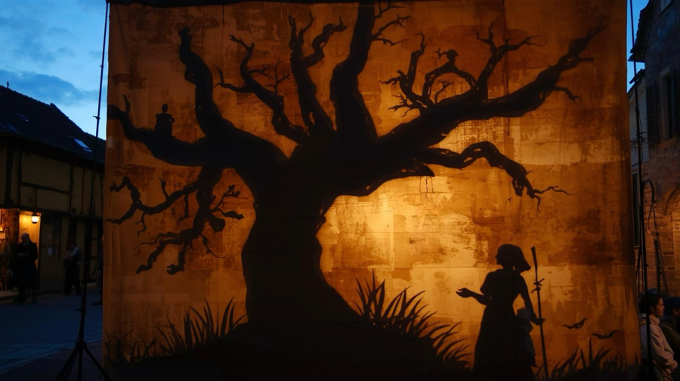
The caravan arrived on the eve of the equinox, dragging the scent of winter and wet earth behind it. In the village square, they stretched a linen sheet taut between two poles. As the sun dipped below the eaves, lamps filled with paraffin and steeped in primrose were lit, turning the cloth into a glowing, translucent window.
The village gathered in the amber light: children jostling for the front, their chatter a bright, chaotic bird-noise; parents standing in the shadows behind them, heavy and silent.
A drum beat—once, twice—and the chatter died. The narrator appeared on the screen, a silhouette of solid black; a masterwork of layered paper, the folds of its clothes cut with precision, its movements guided by wires so fine they vanished into the glare.
The puppet looked out at the hushed crowd, lifted its hat, and bowed.
‘Good evening,’ it whispered, voice like dry leaves. ‘And welcome.’
It paused, head tilting toward the front row.
‘Tonight, I bring you a fable of spring. Your mothers will tell you of the season’s mercy—of rabbits in the tall grass, of new lambs, and eggs painted the colour of the dawn.’ Behind him, shadow-beasts leapt across the screen, elegant and hollow.
‘But if you reach back,’ the narrator continued, its tone deepening, ‘back before your grandmother’s first memory, before your grandmother’s grandmother, to when the world was lean and hungry. Back then, spring was not a gift. It was a trade.’
The screen transformed. Jagged trees and sharp-edged grass rose around the narrator.
‘For the blossom to wake, something must sleep,’ it said. ‘For the bud to break the frost, a debt must be settled.’
A new figure appeared beside the puppet: the Village Elder, a woman whose paper frame was cut to look as gnarled as a root. The narrator bowed, greeted her like a friend, then faded as a huddle of small, shivering silhouettes rose.
‘Each year,’ the narrator’s voice continued, ‘the Elder Woman would gather the youngling. She would seek a child taller than a lamb but no taller than a ewe. One strong and spirited, not wanting weak or sickly.’
On the screen, the puppet-woman pressed a hand to a small shadow’s shoulder, and a treasured toy trembled in the child’s hands.
‘The village would watch. Fathers would look away; mothers would clutch their broods and thank the stars it was not theirs.’
The shivering children faded, until just the crone and child remained.
‘With her hand on the child’s shoulder, she led them into a grove of ancient oaks. She knelt, clearing a circle of bare earth, and stripped the child of their rags. She washed their feet with soil and moss. The child stood perfectly still - mesmerised by the dark ritual.’
‘The change was a quick thing,’ the narrator whispered. ‘The child’s toes lengthened, burrowing into the earth.’
Legs fused into a solid trunk. Arms reached for the sky one last time. Skin thickened into bark. Its head became a crown of budding leaves. And a final, silent cry escaped the puppet’s mouth.
The Elder Woman stood before the new sapling—surrounded by a sudden burst of shadow-snowdrops—plucked the toy from the branches. She looked at another tree, a year older than the sapling. Then at the grove around her—at an oak a hundred years old, where the faint outline of a face was now nothing more than a knot in the wood.
The trees faded until only the crone remained.
The narrator rose behind her, swept its cloak over the woman and she vanished beneath. Then, it leaned forward, its paper eyes fixed on a single child in the front row.
‘Fret not, younglings,’ the puppet said, its voice returning to a soothing lilt. ‘This is but a shadow of the past.’ It gestured to the row of candied eggs lining the base of the stage. ‘Take your treats. Go to your beds. And sleep... Sleep well tonight.’
-
At dawn, the square was empty. The caravan had vanished, leaving only the fading scent of primrose. Children were shaken awake by eager parents, greeted with crushing hugs and the sticky sweet of sugar.
Except in one cottage. There, a mother’s wail broke the morning silence as she stared at an empty bed, and a dusting of fresh, dark soil trailing across the floorboards toward the door.

The Middle Seat

By Dr Moss

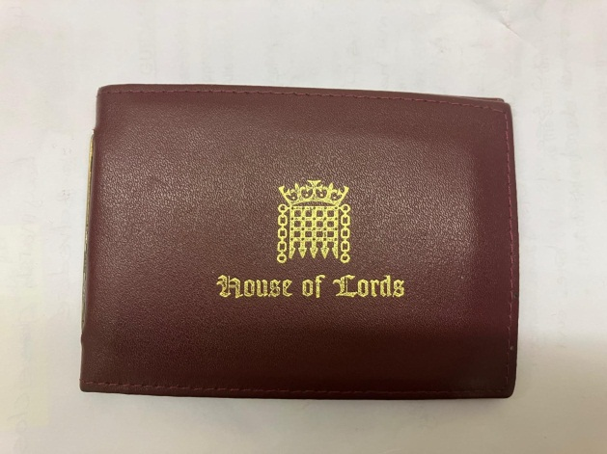
After a long stretch of hard work , and finally completing my recently published book , I decided to escape the English winter for a few days of North African sunshine. While strolling along the high street with that thought in mind, I spotted an attractive five-day all-inclusive offer in a well-known travel agency. I went in without hesitation.
Katie, cheerful and efficient young lady, welcomed me to her desk. Within minutes, we had agreed on a short trip to Tunisia.
When it came to booking the flight, I asked for my usual window seat. As a frequent traveller, I enjoy watching the ever-changing scenery below, clouds shifting shape and colours in daylight, city lights scattered like constellations at night. Unfortunately, the flight was nearly full. With only a few seats remaining, I reluctantly accepted a middle seat in front of the wings.
The day of travel arrived. With a small handbag and a medium-sized suitcase, I headed to Gatwick Airport in south-east London. At the luggage drop-off area, I was surprised to find no traditional airline desks, only a row of self-service machines, much like supermarket checkouts. Uneasy and determined not to send my luggage to Tasmania or Tanzania instead of Tunisia, I asked for assistance.
A young man with a shy smile and an Eastern European accent approached. Apologising in advance, he explained it was his first day using the machines after training. Between us, however, the process went smoothly. My bag disappeared down the conveyor belt, correctly tagged and destined, I hoped for Tunisia.
At security, I made the classic mistake of forgetting to empty all my pockets. Passing through metal detector arch and a routine quick body search revealed a Freedom Pass in my back pocket, housed in a thin brown leather wallet embossed with House of Lords. It had been a gift from a grateful patient who had worked there and insisted I accept it on his final visit before retiring. The officer recognised the emblem, smiled, and waved me through and said ’you are welcome, Sir’.
***
At the departure gate, I settled into a seat with a newspaper. A routine patrol passed by, two female officers accompanied by a small dog wagging enthusiastically. The dog took an interest in my handbag on the floor. I joked that it might smell of my mischievous cat, or perhaps of drugs. The word drugs briefly raised eyebrows, so I had to follow it quickly ’legal drugs, I’m a doctor’, clarification restored their wide smiles, and the patrol moved on satisfied with their dog.
Boarding soon began. I collected two free newspapers from the rack and made my way down the narrow corridor to the aircraft. A friendly hostess guided me to my seat.
The window seat was occupied by a woman in her seventies with short grey hair and glasses. She greeted me. A young man soon took the aisle seat; his family were seated in the front row. As the cabin filled and the seatbelt sign illuminated, I discovered part of my seatbelt trapped beneath my neighbour. She apologised, slightly embarrassed, and freed it.
When I finished reading my newspaper, I put it in the seat pocket in front of me; the lady beside me asked if she could buy it as she loved doing crosswords. I explained that it was free from the rack before the final aeroplane corridor. Surprised, she admitted she had made this journey many times without ever noticing the newspaper rack. She introduced herself as Patricia, travelling to Tunisia to visit her daughter, who had settled there with her husband, working remotely in IT.
It was my first visit to Tunisia, and Patricia generously shared advice. As we talked, we discovered we lived in neighbouring areas of south-east London. The world, it seemed, was smaller than expected.
Later, the aisle-seat passenger’s young child proudly showed his father his drawing of an aeroplane a family with luggage, asking in French whether he liked it. Encouraged, the child showed it to me. I smiled in acknowledgment; the child told his father that the man probably liked it too, so I had to reply “Bien sûr, bravo.” His father laughed and introduced himself as Claude, from Montpellier, a city in France I had once visited as a student, rich with happy memories.
By the time the plane began its descent, I realised I had barely noticed the hours pass. Between Patricia’s stories and Claude’s easy conversation, the middle seat so often dreaded had revealed its unexpected virtue.
As we landed, I wished both passengers well and stepped off the plane ready for my Tunisian adventure, carrying practical tips, fond memories, and a simple reminder:
Sometimes, the best journeys begin in the middle, as well as it is sometimes nice to talk.

