WRITER OF THE MONTH JANUARY 2026

The Winner!
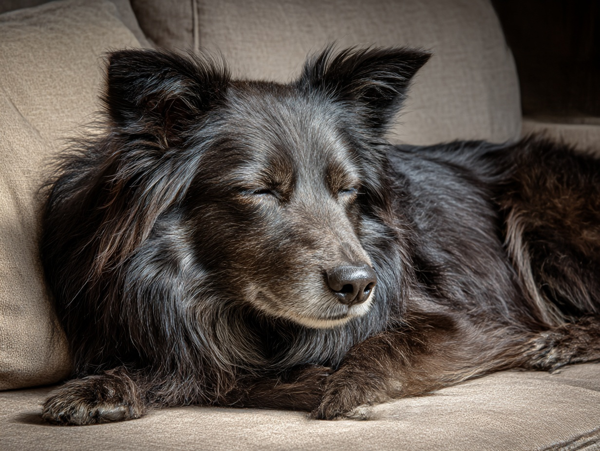

Sparkie
by Martin Domleo
Black, shaggy, mainly collie,
a good-natured bitch, Sparkie.

A good-natured bitch, though not
by nurture: she had spent her
puppy life locked under-stairs,
imprisoned by behaviour
beyond the ken of dog or wolf.

We found her in a refuge,
lake eyes boring, imploring,
top lip folded back, white teeth
sparking a kind of greeting.
The bitch was ours.
Named Sparkie on the spot.

Sparkie wanted marathon runs.
Once we walked Hall Dale,
she five times over,
rounding us up if we strayed.
You could see the worry in her eyes.

Afterwards, as always, she raised
her paws unbidden for cleaning.
We couldn’t chide her
for the matted hairs that clung
like Velcro to carpets and chairs.
Not to her face.

Lake eyes reflecting moons
over the sheepfold,
watching, waiting: Sparkie
could melt you with one look.

She died yesterday, her guts
racked with cancer, still placid,
still trusting, raising a paw
for her harness before
clawing herself unsteadily
into the car
for a short last journey,

deeper than the deepest dale,
longer than the Ladybower.

Other entries in no particular order
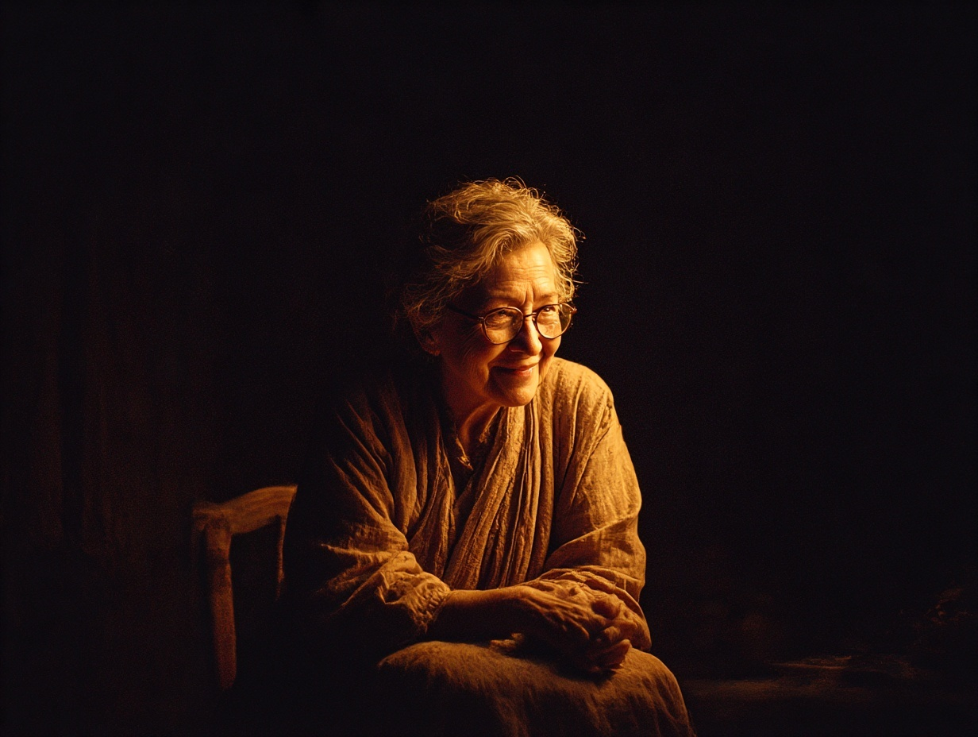

Light versus Dark
by Ethel Corduff

Dark and light have many facets
I don't like when the clocks change
and it is dark mid-afternoon.
When electrics fail and we sit in the dark
avoiding driving in the dark.
Darkness can be dangerous.

People can be affected too
At a funeral, they wear dark clothes.
Seen as a sign of respect.
Some have dark hair, often dyed.
Dark looks can be exchanged
when upset.

I like to wake to light
and to switch the light on
in the evening.
We enjoy the long, light days
It is safer.
Wearing light clothes then feels freer

One can feel lightheaded
for many reasons.
Light bulb moments can lead
to major changes.
She was as light as a quill.
A loved one can be the light of your life.

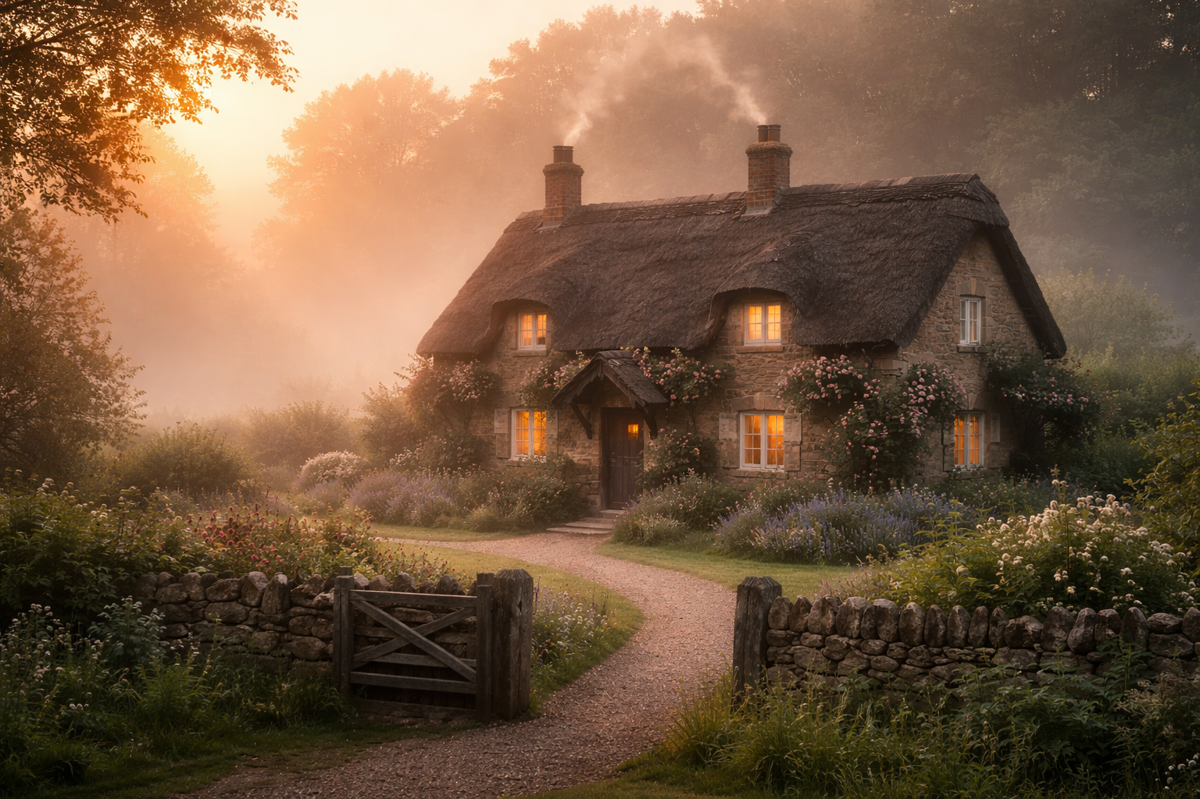
Night and Day
By Maggie Smith

The darkness like a fog the house obscures,
And those at home feel insecure,
The flickering candle makes shadows that haunt,
The darkness its oppression flaunts,
Like a smothering blanket across the room,
Especially on a night when there is no moon,
Moving slowly the time it creeps,
Then a glimmer of light into the room it peeps,
Then slowly, slowly rises the golden sun,
And now finally daytime has come,
All the nighttime fears are past,
And sunbeams dance on the wall at last.

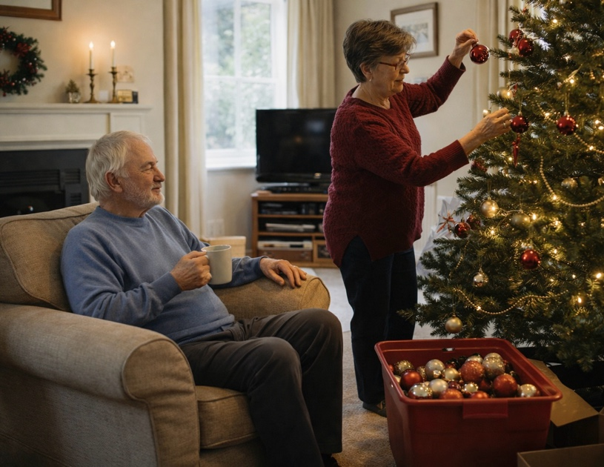

Drawing In
By Peter Hankins

‘So, I suppose the days are already getting longer again,’ said Molly as she packed the Christmas tree decorations away for another year. She frowned: their old plastic tree was now shedding nearly as many needles as a real one.
‘What if they didn’t?’ asked Alec, ensconced in an armchair with a cup of tea. He never helped with the decorations, saying that Molly had her own way of doing it and if he tried to help he would just annoy her. There was unfortunately an element of truth in that.
‘If it never got light I suppose it would be the end of the world,’ she said, ‘but it’s astronomically impossible.’ In February, though, after walking into a signpost on their regular Sunday walk, Alec blamed the poor light.
‘The days just keep getting shorter and darker,’ he said, once they got home and sat down.
‘No they don’t. Don’t be stupid.’
‘They do for me. Spring isn’t coming. I think I’m on my way out, Molly. I’m seventy, after all. Three score years and ten. This was my last solar year, and God is gently turning off the lights for me.’
‘You’re not dying. That steak and kidney pie last night served four according to Sainsbury’s and you had a good half of it.’
He shrugged.
‘I’m not afraid,’ he said, ‘I’ve had a good life.’
‘The funny thing is, you’ve actually been a lot more cheerful lately,’ said his wife, ‘we haven’t had the daily critique of the Prime Minister’s failings for a while now.’
‘Ah, well…’ began Alec.
‘No! No. That was not a request.’
In March she sat him down for a serious talk.
‘Are you trying to kill yourself?’ she demanded.
‘No, no. It won’t be long now. My time is over. I don’t need to rush it.’
‘Then why did you step out right in front of the Superloop bus? That driver must have had amazing reflexes, or you would have been flattened.’
‘Everything’s so dark now. I couldn’t see. God is drawing the curtains and calling me home.’
‘No, but I’m calling a psychiatrist,’ she said.

In May Alec had his cataracts removed and the world became clear to him again. As she drove him home after the second eye was done, Molly smiled.
‘That’s better, isn’t it?’ she said.
‘Yes, I suppose so.’
‘Only suppose so? You’re not dying and you can see things again?’
‘Yes, I know. It’s amazing. The only thing is, I’m going to have to start reading the bloody news again now.’
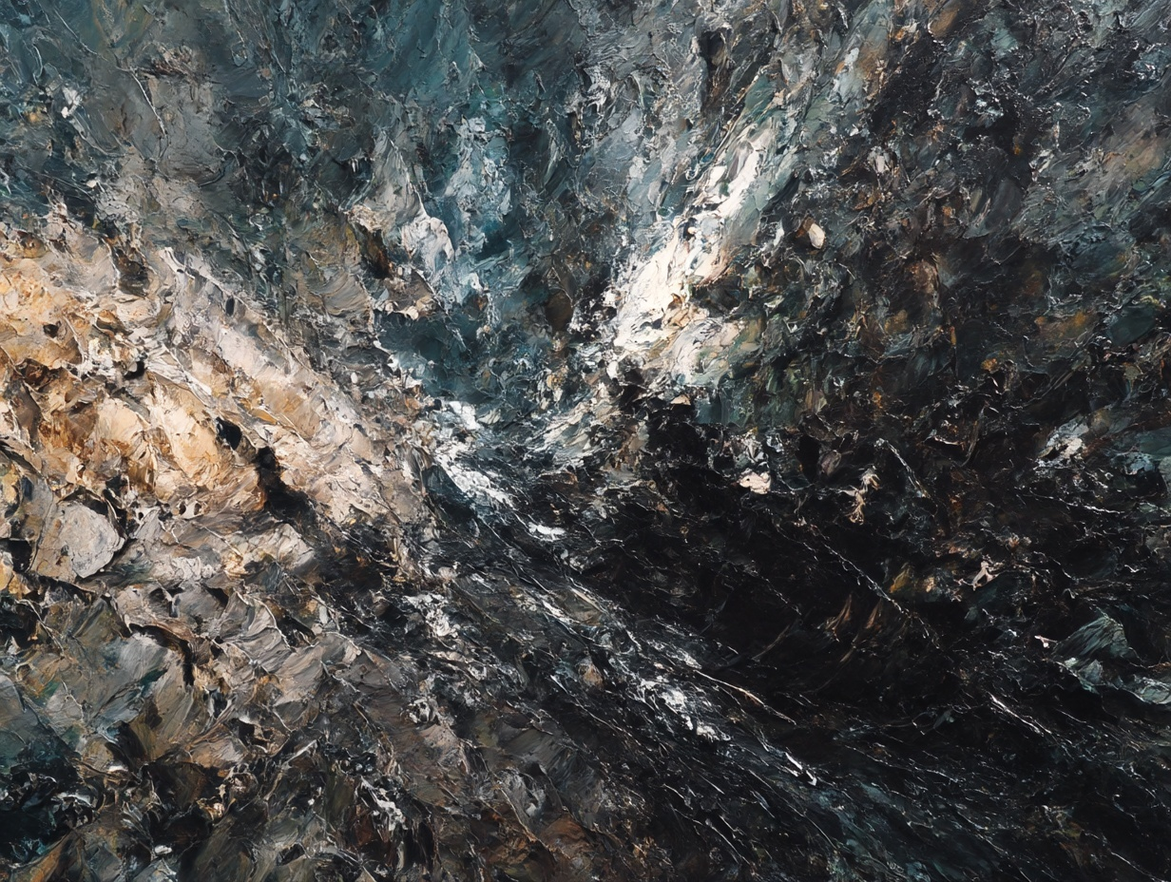
Absence of light
by Stella Howells
Absence of light
Equals dark.

Night Lights
Dark days
Candle lights
Darkness falls

Dark deeds
Dark shadows
Dark web
Dark intent

Light – touch
Light – hearted
Light – fingered
Light - headed

See the light
At the end
Of the tunnel
Run towards the light,

Dark corners
Hide demons
Run away, run away.

Light is without weight,
Darkness weighs heavy,
Dragging us into the abyss.

Darkness falls, light blazes.
A constant battle between the two,
In every aspect of life and living.

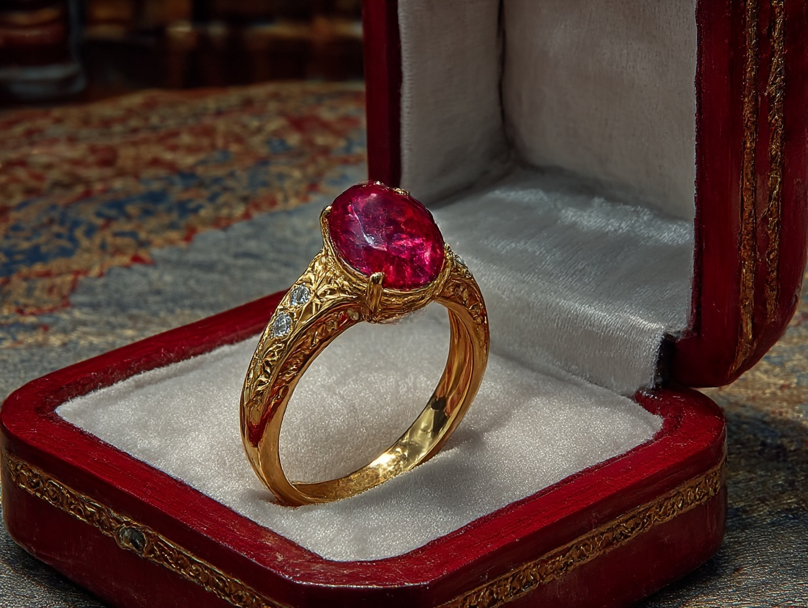
Something Special.
By Mike Jackson
Thank goodness, I am walking again. But not good enough-it’s going to take a long time. But I must go to his flat. The doctors say I should not even try this long walk from the bus, not until my broken legs are really better. It’s been four months, but I must. It’s very hot out here and my skin cannot take the hot sunlight. 4th floor but I’ll take the lift. It’s many stairs, but we used to run up those stairs, trying to keep fit.
Oh no! The lift is broken down. What can I do now? But I’ve got to get there. Sixty- eight steps. But I must give it a try!
Seventeen. How have I done that? Sit on the top step? No keep going. Ouch, that hurt!
Be more careful girl. More slowly, left foot first.
Wish he was here. Oh, why isn’t he here? We always ran up, trying to do it faster and faster.
Twenty- two. Why him and not me? Twenty- seven. Stop it! No crying now!
Told him after the accident, not a bloody accident!
My skin is burning in this light, this sun’s so hot through the window!
Thirty - six. And I hate long skirts. But with the state of my legs, nothing shorter now, or even possibly forever. But I must keep going.
Forty - two. Ouch! My ankle! Everything hurts.
More physio tomorrow- how long I do not know. That pulled my back again!
Miss you so. God, I ache! Come on, get up again. I really have to get there.
Almost your last words, when they took me in my chair to your bed.
‘The flat, the flat.’ Your voice was low. I clung to your hand.
‘Go to the flat. The drawer on my side of the bed, top one. Something special.’
but you never said any more. Bloody lorry driver! They said he was drunk!
Fifty- three. How have I done that? That’s thinking of you. Oh legs, please, get me there!
He’ll be waiting at the flat for me. Don’t be silly, girl, no he won’t. My love is dead now, he won’t be there.
Come on, only thirteen to go, I must go on. No unlucky thirteen please, please. The pain is awful!
I’m almost done, four more. Nearly. Come on legs, please take me.
Sixty- eight. Oh yes. There’s the door. My key fits, I’m in. Must sit. No, must go to the bedroom. But it’s so dark in here. I need some light. Oh no! The electricity is off! But I still have my small torch. Bloody hell, it’s working. Shall I open the drawer? Oh, I must for him. ‘Something special’ he said. A small red bag, a small red box. I open it. Oh you wonderful man, my engagement ring!

