

Welcome to Croydon Writers Newsletter
Summer 2025.

It’s been a while…

Following the sudden death of our Chair, Michael Round, in July 2024, the committee has taken on the substantial task of keeping the group alive. They have undertaken monthly planning meetings to ensure the group runs smoothly and continues to offer a supportive and welcoming space for everyone interested in developing their own writing.
Monthly Monday evening meetings have covered a range of topics including poetry,
pen – portraits, giving feedback, a Christmas quiz and social event, two invited author talks, a stand – up comedy session and the A.G.M.
Attendance remains steady, with between 6 and 12 people coming regularly to the United Reformed Church halls. With a focus on building the overall membership, several initiatives have been put into place. The constitution was updated and social media revamped.

The first Michael Round memorial competition is attracting entries from far and wide. Highly appropriate, as that is the theme for the competition!
Please do think about entering, you still have plenty of time to get your ideas flowing.
Go to the website for details. www.croydonwriters.co.uk

Jo’s Crochet - Inside Crochet Magazine
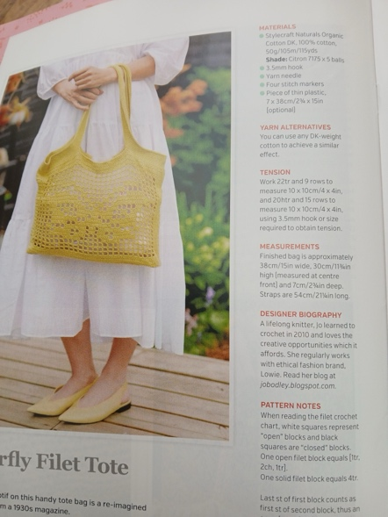

Talented member, Jo Bodley, not only writes fiction and performs her own one - woman comedy act, but also designs crochet patterns, many of which have been published in various magazines.
Her latest design for a “Butterfly Filet Tote”
is to be found in “Inside Crochet “magazine issue 179
and is a fine example of her skills with a hook and yarn
as well as pattern design and publication, with all its complexities.
Her bags are now on sale at “Lowie”,
Half Moon Lane, Herne Hill.

Congratulations, Jo!

Flash Fiction.

Jo also led the session on Flash Fiction at our July meeting. Here is a small selection of the writing members produced from prompts. The target was 100 words.

Far and Wide
Mr Smedley had travelled this route every day for thirty years, to the offices of Messers Far and Wide. Both of the Founders were long dead, and the company was run by Young Mr Wide - ‘the Wide Boy’ as they secretly called him.
Smedley reflected that if all his commuting days could be superimposed, this street would be thronged with jostling Smedleys. A sobering thought.
He had, he thought, travelled many miles, but ironically, not far and never wide. He snickered at his own sharpness and suddenly stopped.
‘You know,’ he said, aloud, ‘I’m not going in.’
And he didn’t.

Peter Hankins

My Coffee Cup
I cannot invent characters, but I don’t need to. I go to the coffee shop. When I get my order, there is always a name scrawled on the paper cup, a name that strongly evokes a vital, interesting fictional character. Pollotrio, who must have been the henchman of the hero in a lost Shakespeare play. Bataaa, surely a barbarian? Perhaps he rode with Attila, but certainly he was an implacable enemy of civilisation. Then there was Pentilea, the beautiful lady who graced the salons of eighteenth-century Paris.
Someone told me it’s supposed to be my name, but that’s ridiculous.

Peter Hankins

Jeremy Dixon wrote this piece, with this explanation about the inspiration for his idea:

“It was written at short notice given the suggested title "My Coffee Cup", and I had earlier seen a woman in a cafe with two cups of coffee on her table, but no-one seemed to join her.”
She finished her cup of coffee and called across the cafe to the waiter for another.When he brought it he tried to take away the first cup, but she insisted it should stay with her. The waiter didn't think it worth arguing about.
She finished the second cup and ordered another. When it arrived she put her arms protectively round the first two.
She finished the third cup and ordered a fourth. As the waiter had foreseen, she made clear she did not want the first three cups to be removed.
The fourth cup arrived. The first three cups had been of the same design but the fourth was of a different pattern.
She looked at it intently and made no attempt to drink.
"Yes," she said, "I was being careful to keep the cups so that you couldn't wash any of them and serve them up to me again.What has happened is what I hoped would happen. The fourth cup is, as you may be aware, of a very rare design.It was the type we used when I owned this cafe."
"Oh, I didn't know that" said the wait"You may not," said the customer, "but your employers should know that the crockery was not included in the contract when the business was sold.They are about to find themselves sued for appropriating property they've no right to."
A birthday...

Maisie Dance celebrates her 90th Birthday

Congratulations to Maisie Dance on her 90th birthday.
Maisie is our longest serving member, having joined Croydon Writers in the 1980s. She had found out about it from a poster designed by the then secretary, Daphne Moss. It was called Croydon Writers Circle then. Maisie had already started writing and had a few items she was already published.
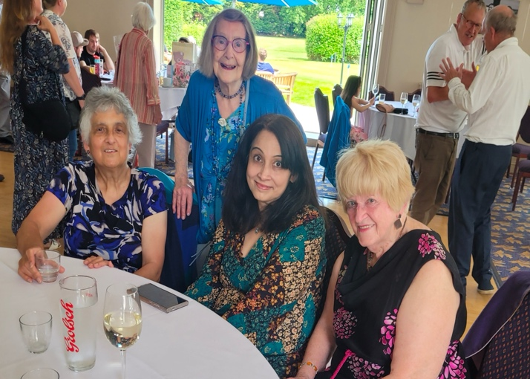
Maisie (standing), l to r, Maya,Roopa.Ethel.

Meetings were then held fortnightly in the small hall at URC and there were also afternoon workshops for a while. Maisie helped by making coffees and collecting the money. She was later asked to be membership secretary. Later on, she had a phone call from the President Jean Bowden, asking her to take over as secretary, as the secretary Doris was in hospital. Maisie had to look for and arrange speakers nearly every month. She was secretary for twenty-two years, all the time writing and publishing.
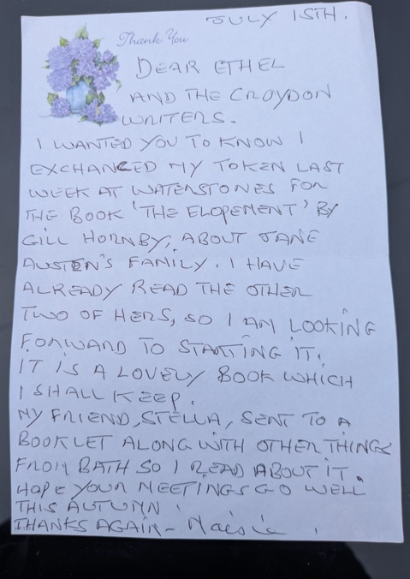
Best of Britain magazine has published a lot of her work and appreciates the quality of Maisie’s writing, by now accepting her handwritten items as Maisie no longer uses a computer. Joining in the 1990’s, Maya Chatterjee recalls Maisie's hospitality, tea and cake, and enjoying her engaging short stories and articles. Maisie often arranged refreshments while organising the meeting, even washing up afterwards, Maya said Maisie had a lovely poetic way of writing. They remain close friends. Maisie recalls meeting several Croydon Mayors at Croydon Writers events. One was the late Maggie Mansell in the Green Room at the Fairfield Hall at Croydon Writers 70th Anniversary. Maisie was involved in the anthology “Croydon as I see it” and with children from local primary schools reciting their own poems about Croydon.

Maisie was brought up on a smallholding in Woodmansterne, which was the theme of of her very successful book “Two Acres of Love” published by the Honeywood Museum.This has been reprinted at least five times and is still on sale at the Honeywood Museum, where Maisie had her book launches.
Recently, a lady who organises walks among the small holdings where Maisie used to live wants Maisie to come and talk to the group. Maisie has a great interest in gardening and plants, as she grew up in that environment, Her daughter, a florist, had the shop “Pure Flowers” in the Whitgift Centre and Maisie helped her in the shop a few days a week and was very friendly with the customers who bought flowers. Maisie arranged the buttonhole flowers for Jean Bowden's funeral. Maisie also organised regular coffee mornings for the blind for years and collected a lot of money for them.
I had the pleasure of attending a few. Maya describes Maisie as kind, very thoughtful, generous and uncomplaining. I echo those sentiments, she made everyone feel welcome at meetings and took a special interest in their writing. Existing members of Croydon Writers who knew Maisie would remember that. Long may Maisie enjoy writing. She is truly an inspiration.

Ethel Corduff

An Obituary...
Sidney Moss 1927 – 2023

Sidney Moss was a long-time supporter and benefactor to Croydon Writers. He donated £500 annually to Croydon Writers in the form of the Sidney Moss prize.
He was born in 1927. His late wife Daphne was Croydon Writers Secretary for a long period prior to Maisie Dance. Sidney was an accountant, and the managing director of the Jewish Chronicle for years and was also involved in charitable works. He and Daphne had three sons and a daughter, Mandy, who went to live in Israel in her twenties and married there. Her daughter Emily Damari visited her grandfather Sidney every year in his home in Beckenham.
Mandy’s home in south Israel was attacked by terrorists in October 2023, but she was spared death when their bullet jammed the lock of the room she was in. However, her daughter Emily was abducted from her home and taken hostage and suffered gunshot wounds to her hand, causing her to lose two fingers and her dog was shot. She was the only British hostage. Her mother’s very public campaign to free her brought much publicity.
What a worry for Sidney in his declining years. Sadly, he died last year, aged ninety-seven, knowing his granddaughter was still a captor. Emily was eventually released and lauded for her bravery by fellow hostages.

Croydon Writers will fondly remember Sidney Moss for his kindness, generosity and interest.

Ethel Corduff

Berlin Beckons.


Congratulations to one of our youngest attendees , Ella Nanton, who is off to Berlin shortly, having secured an internship
at the Anahita Sadighi Gallery.
Ella gained her degree in Design for Theatre and Live Performance
and has been spending her time volunteering with St. Marks amateur dramatic group as their stage manager and set designer.
She will develop her skills in exhibition design and installation,
social media presence and live events.
We wish her well and look forward to hearing about her experiences when she returns.

Croydon takes centre stage.


Local authors have been busy –
Will Noble joined us to talk about his book
“Croydonopolis”
and gave an insight in to the history of the borough which has always aspired to be a city.

Follow this link to read more about Will in an interview in Croydonist. www.croydonist.co.uk

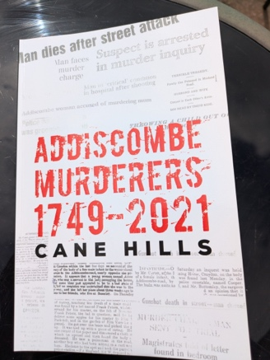
Cane Hills
was on hand this month in local hostelry,
The Claret and Ale, to sign and talk about his non – fiction book,
“Addiscombe Murderers 1749 - 2021.”
He spent many hours researching each murder,
using resources at both the British Library and the National Archives.
Tapping into a very current genre, Cane Hills explores the shadowy side of human nature in an accessible collection of true crime events which are relevant today.

Both books show what a colourful and interesting place we live in!

Blogs , instagram and websites.

The website is gaining interest. Peter Hankins has compiled data showing the number of visits to the site. www.croydonwriters.co.uk

Peter writes a regular blog and also keeps us informed about many of the writing competitions out there on the internet. “Seen and Done” can be accessed through the Wordpress site. https://seen-and-done.com
He also has a story published on Wattpad -
https://www.wattpad.com/story/progress

Stella Howells also writes a travel – focussed blog, based on her travels and observations whilst out and about in this country and often much farther afield. She posts regularly on Instagram and has written articles for a variety of publications, including the D.H.Lawrence Society.
Instagram @stellthesame https://travellingyarns.home.blog

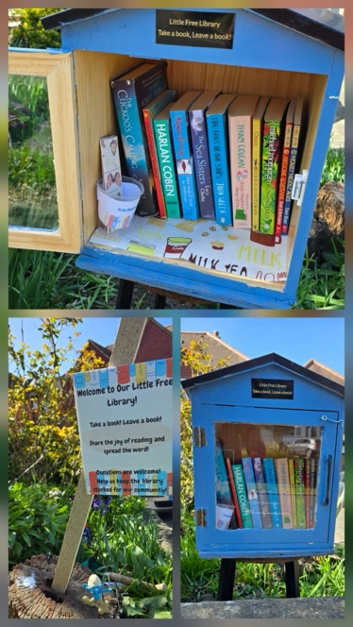
My Little Free Library.
My Little Free Library is a bright blue book box that sits cheerfully in our front garden, open to everyone in the community. The concept is simple: take a book, leave a book.
It includes books for both children and adults and is my small attempt to spread the joy of reading in our neighbourhood.

It adds a quiet joy to my day to return from work and see if someone has taken a book or left one behind. The most fulfilling moments are when I find a handwritten note in the guest book from a visitor saying that stopping by the library brightened their day.

It’s a small gesture, but one I hope will help foster a love of reading and encourage friendly connections within our community.

Roopa says she posts on Instagram each time she stocks the LFL with new books.
What a lovely ,practical idea!
Thanks, Roopa.

Roopa Banerjee @roopa_b

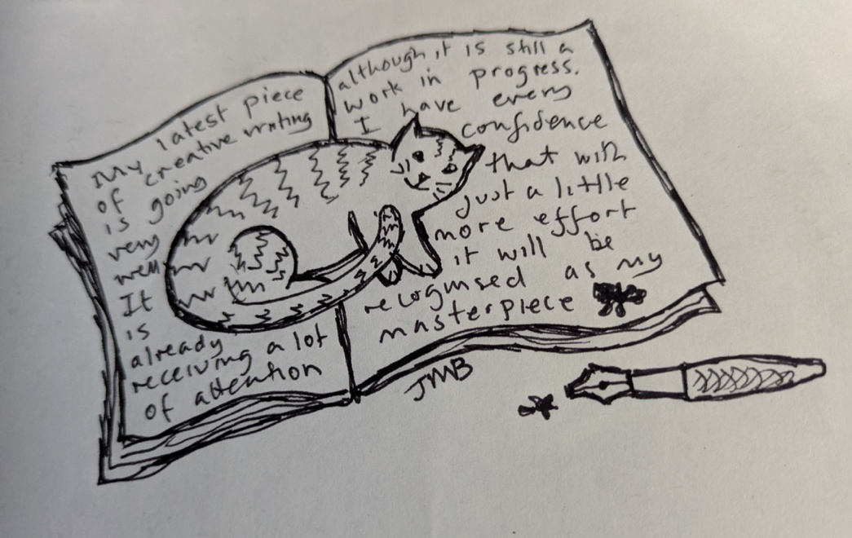

Cartoon by Jo.

Looking forward to August, there will be no Monday evening meeting, however, Jo is kindly hosting a social afternoon on Saturday 9th August, all welcome. See website.

The next Monday meeting will be on 8th September when Peter will be giving an insight into the labrynth of competitions and tips for entering.
The committee will meet again on 22nd September.
Do get in touch if you have any suggestions or ideas for the group or writing you would like to share.

The Committee:

Chair : Mike Jackson albert9881.pa@gmail.com
Treasurer: Ethel Corduff ecorduff@hotmail.com
Secretary: Stella Howells s.howells@btinternet.com

Committee members:

Jeremy Dixon pauldixon2030@gmail.com
Jo Bodley jobodley@googlemail.com

Web Design and content:
Peter Hankins hankinspeter@gmail.com

Lastly -
A rather sobering anniversary in August – on 17th August 1896,
Mrs. Bridget Driscoll, of Croydon, Surrey became the first pedestrian in Britain to die after being hit by a car.

There’s definitely a back story, factual or imagined, to be written about poor Bridget’s sad demise. Give it a try!

